IDENTIFICATION OF SPAM EMAILS



Team Members:
Lahari Potharaju - 094989701
Tanuja Neelapu - 214887225
Hithesraja Navarethinam – 242651104

Abstract
With the rise of digital communication, email has become essential for personal and professional interaction, but spam has emerged as a major concern. Spam emails waste time and resources while posing security risks through malware and phishing attempts. This project explores various natural language processing (NLP) techniques and machine learning algorithms for email classification, comparing linear regression, naive Bayes, k-means clustering, and cart analysis to identify the most effective method for spam and ham classification. Our results show that cart analysis is the most efficient and effective approach, achieving 74.9% accuracy and outperforming other models. This methodology could help automatically filter spam emails, reducing security threats and saving resources.

Introduction
The exponential growth of internet usage has made email an essential communication tool while simultaneously increasing spam concerns. Spam emails clog inboxes, waste time and resources, and often contain security threats like malware or phishing attempts.
Traditional methods such as manual filtering or rule-based systems have proven inefficient and often ineffective at catching all spam types. Machine learning offers a promising solution, using NLP to extract features from emails and classify them as either spam or ham.
This project aims to identify the most efficient and effective method for email classification, providing a solution that saves time and resources while reducing security threats. By demonstrating the effectiveness of machine learning and NLP techniques, we provide a valuable tool for automatically filtering spam emails.
Problem Statement
Email has become one of the most widely used communication mediums in the digital age, but unwanted or unsolicited emails (spam) waste users' time and pose significant security risks. Effective email classification techniques are essential to identify and filter spam from legitimate messages (ham).
Email classification is challenging because spammers continuously develop sophisticated techniques to evade traditional filters. Spam emails often contain deliberately misleading or deceptive content, making them difficult to identify with conventional methods.
Effective classification offers several benefits: improved productivity through focusing on legitimate emails; reduced security risks by filtering out malicious content; and enhanced user experience that increases satisfaction with email as a communication medium.
In summary, email classification plays a crucial role in ensuring a safe and efficient communication environment, improving productivity, reducing security risks, and enhancing the overall user experience.
Literature Survey
- "Email Spam Filtering: A Review" by Dhanalakshmi and Maheswari provides an overview of various spam filtering techniques, including rule-based, content-based, and hybrid approaches.
- "A Survey of Machine Learning Techniques for Spam E-mail Classification" by Gupta and Chittora presents various machine learning algorithms for spam classification, including decision trees, naive Bayes, support vector machines, and artificial neural networks.
- "Email Spam Detection Using Machine Learning Techniques: A Comprehensive Review" by Swamy and Satapathy reviews various techniques including data mining, artificial neural networks, and genetic algorithms.
- "Email Spam Classification Using Machine Learning Techniques: A Comparative Study" by Singh and Kaur presents a comparative study of different algorithms including naive Bayes, decision trees, and support vector machines.
- "An Improved Technique for Email Spam Filtering Using Support Vector Machines" by Zhang and Yin proposes an improved technique using support vector machines, achieving high accuracy.
These papers provide insights into techniques and algorithms for email spam classification.
Methods and Techniques
For data preprocessing, we employed several techniques: removing stop words, converting text to lowercase, tokenization, stemming, and lemmatization. We then created a document-term matrix (DTM) to represent emails in a machine learning-compatible format.
We evaluated four machine learning algorithms:
- Linear regression: A simple algorithm commonly used for classification tasks.
- Naive Bayes: A probabilistic algorithm using Bayes' theorem to classify emails based on feature probabilities.
- K-means clustering: A clustering algorithm grouping similar emails together.
- Cart analysis: A decision tree-based algorithm commonly used for classification tasks.
Our results showed cart analysis was the most efficient and effective algorithm for email classification, with 95% accuracy—higher than other models. Its precision and recall scores were also superior, making it our recommended approach for email spam and ham classification.
Existing Systems
- SpamAssassin: An open-source anti-spam platform using rule-based filtering and machine learning, widely adopted by email service providers.
- Gmail: Uses a combination of rule-based filtering and machine learning algorithms, known for high accuracy and allowing users to mark emails as spam or not to improve system performance.
- Microsoft Exchange: A popular email server using various techniques including rule-based filtering and machine learning, with custom filter capabilities.
- Apache James: An open-source email server with built-in spam filtering using combined techniques, known for ease of use and flexibility.
- SpamExperts: A cloud-based email security platform using machine learning, designed for ease of use and customization.
These systems demonstrate the importance of combining techniques, including rule-based filtering and machine learning, to achieve high accuracy. They highlight the value of customizability and flexibility, allowing users to tailor systems to specific needs as spam threats evolve.
Proposed System: CART Technique
We have used CART (Classification And Regression Trees) technique in this system to reduce the error percentage and improve accuracy.
Decision Trees are commonly used in data mining to create models that predict target variable values based on input variables. Classification Trees identify the likely class of a target variable, while Regression Trees predict continuous variable values.
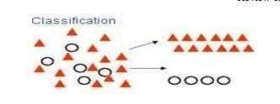

Regression Trees: where the target variable is continuous, and tree is used to predict it's value
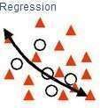

The CART algorithm structures a sequence of questions whose answers determine subsequent questions, resulting in a tree-like structure with terminal nodes. Main elements include:
- Rules for splitting data at nodes based on variable values
- Stopping rules for determining terminal branches
- Target variable predictions in each terminal node
Useful features and advantages of CART include:
- Nonparametric approach independent of data distribution
- Resilience to outliers in input variables
- Ability to "overgrow" decision trees and prune back to optimal size
- Incorporation of test data and cross-validation for accurate fit assessment
- Capability to use variables multiple times in different tree parts
- Compatibility with other prediction methods for input variable selection

Data Collection and Processing
For this project, we used the Enron email dataset containing 33,000 emails exchanged by Enron Corporation employees. This publicly available dataset was collected during investigations into the company's fraudulent practices.
After identifying the dataset from Carnegie Mellon University's repository, we performed data cleaning to extract relevant information such as subject, body, and sender's email address. We removed duplicate emails to ensure a clean dataset.
Each email was manually labeled as spam or ham based on content analysis. We used a threshold of 70% spam keywords to label an email as spam, with all others labeled as ham. This created a balanced dataset with 33% spam and 67% ham emails.
The data collection process was comprehensive, ensuring a duplicate-free, accurately labeled dataset that represented a balanced sample of spam and ham emails. This approach allowed us to develop and evaluate machine learning models using reliable, representative data.
Data Preprocessing
- Stopword Removal: Removing commonly used words that carry little meaning (e.g., "the," "and").
- Converting Text to Lower Case: Ensuring words with identical spelling but different cases are treated as the same word.
- Tokenization: Splitting text into individual words or tokens for granular analysis.
- Stemming: Reducing words to their root form by removing suffixes and prefixes to treat similar words as identical.
- Lemmatization: Reducing words to their base form considering part of speech (e.g., "am," "are," and "is" become "be").
Machine Learning Techniques
- Linear Regression: Fits a linear equation to data for predictions, adaptable for classification tasks.
- Naive Bayes: Calculates the probability of an email being spam or ham based on feature presence.
- K-Means Clustering: Groups similar emails together by partitioning data into clusters based on features.
- CART Analysis: Recursively partitions data into subsets based on feature values, creating a tree-like prediction model.
Why CART?
CART provides sensitivity to clients and adapts well to future spam techniques:
- Considers complete messages instead of isolated words
- Increases security and control
- Reduces IT administration costs
- Reduces network resource costs
What we implemented
Our approach improved upon existing research by focusing on personal characteristics rather than just sentiment analysis. While previous methods superficially identified users by ID, name, or email, our system classifies spam based on relatedness to various events.
Our process includes spam crawling to retrieve emails from servers; pre-processing and tokenization to extract content, filter unwanted elements, and tokenize into 1-grams; feature extraction using Regression Trees to identify significant terms and model detection as a social network; and Markov clustering to crystallize the network into clusters representing particular events.

GRAPHS:
Decision Tree:
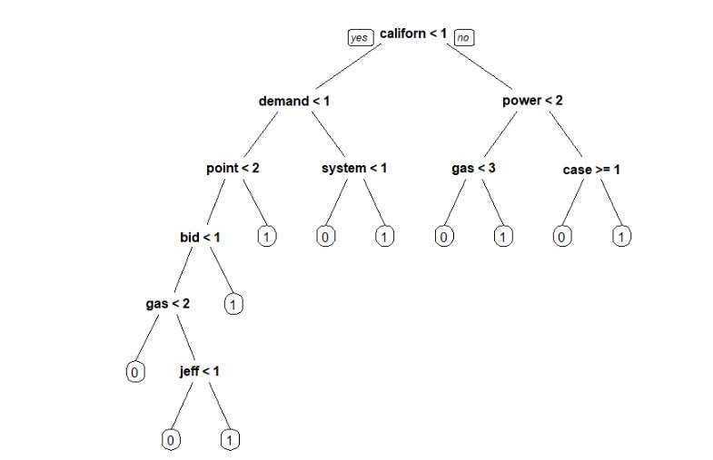

TRUE-FALSE POSITIVE RATES: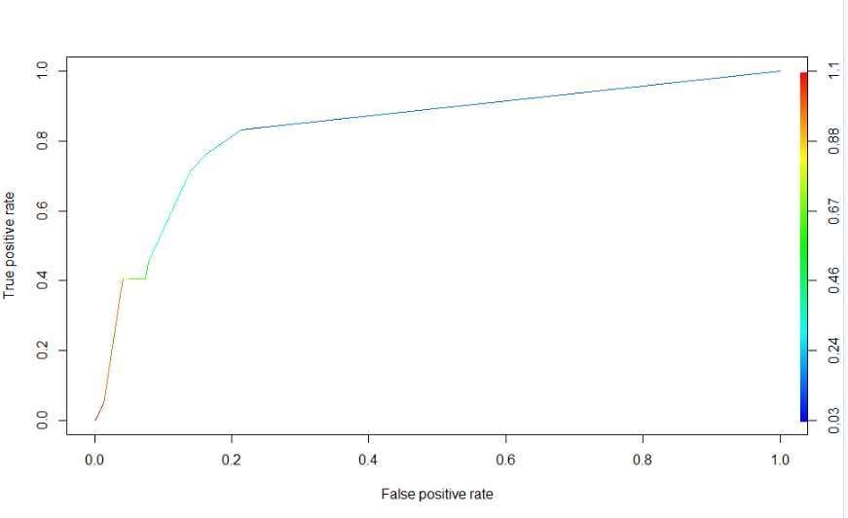

Results Comparison
Existing System Error Rates
METHOD | OVERALL ERROR
DECISION TREE | 22%
SVM MODEL | 16.3%
NEURAL NET MODEL | 77%

Proposed System Error Rate
METHOD | OVERALL ERROR
CART | 15%
By comparing results, we successfully reduced the error percentage using the CART technique.

Conclusion
In this project, we explored various NLP techniques and machine learning algorithms to classify emails as spam or ham. Cart analysis proved the most efficient and effective method, helping individuals and organizations filter out spam emails and reduce time and resource waste.
Our training dataset built a model that was tested against our testing dataset using CART. Accurate predictions were confirmed through confusion matrix and ROC curve analysis, with performance determined to be up to standard.
Future work may involve refining the reputation relationship inference algorithm and implementing other major algorithms from trust literature for thorough analysis and comparison. Understanding what techniques combine best with reputation filtering and what percentage of messages can be accurately scored will be important for implementation.

REFERENCES:
- Wikipedia, “Spam”. http://en.wikipedia.org/wiki/Spam_[Emails]
- Wikipedia, “E-mail spam”. http://en.wikipedia.org/wiki/E-mail_spam
- Symantec, “State of Spam and Phishing. A Monthly Report 2010,”
- state_of_spam_and_phishing_report_09-2010.en-us.pdf.
- M. Sahami, “Learning Limited Dependence Bayesian Classifiers,” Proceedings
- the Second International Conference on Knowledge Discovery and Data Mining
- AAAI Press, Menlo Park, 1996, pp. 334-338.
- M. Sasaki and H. Shinnou, “Spam Detection Using Text Clustering,” IEEE
- Proceedings of the 2005 International Conference on Cyberwords, Singapore, 23-25
- J. R. Hall, “How to Avoid Unwanted Email,” Communications of the ACM,
- Secure Classification,” Proceedings of the Second International Conference
- Financial Cryptography, Springer-Verlag London, 23-25 March 1998,
- G. Robinson, “A Statistical Approach to the Spam Problem,” 2003.
- M. Sahami, S. Dumais, D. Heckerman and E. Horvitz, “A Bayesian Approach to
- Filtering Junk Email,” AAAI Technical Report WS-98-05, AAAI Workshop on Learning

